OCR GCE A Level

COMPUTER SCIENCE PROJECT

H446-03
Name: Filips Reisons
College ID: 20221892

Monoux College: 13425
Candidate Number: <INSERT CANDIDATE NUMBER>

Title of Project: The hunt for Blue November
Date of Project: 16/11/22
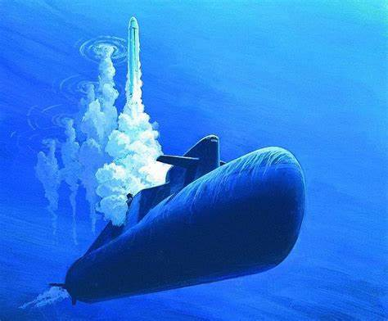

Table of Contents
Analysis 3
Design 3
Systems diagram 3
Developing the coded solution (“The development story”) 3
Evaluation 3
Project Appendixes 4

Analysis of the problem

3.1.1 Problem identification
For my project I am planning to create a game akin to older submarine simulation games such as 1988’s Red storm rising and 1996’s Silent hunter 1. In these games you control a submarine which you use to attack enemy ships and submarines with torpedoes and missiles while evading detection. They are single player against ai enemies which search for you and attack you with depth charges and torpedoes. To win a mission, you must defeat all enemies without losing all your health and subsequently being defeated. As these games are a part of the simulation genre, they are quite in depth and feature realism unlike a more arcade type game.

3.1.2 project definition
For my project I hope to produce a game where the player will control a submarine, using it and its weapons to destroy enemy ships that will be trying to destroy the player. This will occur in real time, with the player controlling direction, speed, depth and weapon employment through text commands from a given list. To inform the player’s choices, there will be a map of the submarine’s surroundings marked with all detected enemies and incoming weapons. The player will be destroyed after being hit by a guided enemy weapon, if I add a difficulty setting then this could be changed. There are no levels, on start of a new game enemies will be randomly placed and once they are all defeated the player will gain score and the option to play another match.
Features: A map with detected entities; A text box for inputting commands; indicators for depth, speed, bearing

3.1.3 How the problem can be solved by Computational Thinking
This problem is well suited for a computer because it can be solved via computational methods. This is because it is easily abstracted to algorithms that are run on a given set of values repetitively to drive the actions of enemies while taking input from the player to drive their own actions.

Thinking abstractly
I have many ideas for features I want to add, but if I try to add them all I will inevitably fail. I need to separate only the features necessary for the game so that I can make an initial working build before adding any complex systems and features to increase realism. These necessary features include:
- One enemy type
- One weapon type
- A map so the player knows what’s around them
- A file containing information on every active entity
- An algorithm to make the enemy do things
- An algorithm to make weapons home in on their targets
- An input method for the player
- A cycle that runs algorithms while the player makes decisions to make it real-time

Thinking ahead
This is a way look into the future and get ideas and a structure down before starting anything so that the goals are clear.
- I will use python in combination with pygame as I am familiar with python and pygame is the most popular and well supported engine for it
- Inputs will be through text based commands
- Outputs will come as objects on the map and text outputs
- The player could receive a medal depending on how they perform

Thinking proCEDurally
For the code, I will need a system for where every second that passes in game, each enemy vehicle and guided weapon moves in a direction with a speed of its choosing determined by its ai. As all enemy entities of the same type e.g., ships would share the same ai, I will simply have to run each active entity through the ai to get it to determine its own course of action. The game is broken down into:
- Accepting player inputs
- Tracking entity locations
- Algorithms for enemy and weapon ai
- Displaying entity locations

Thinking logically
The player doesn’t require every piece of information available to them. All they need is a general sense of where their enemies are located, their bearing, speed and depth. Limiting the information they receive will reduce their workload and keep players from becoming overwhelmed.
My code will have to run many checks a second to see if direct hits are scored, if a complete miss occurred, if the enemy ai should reconsider its actions, etc.

Thinking concurrently
Ideally, in-game time would pass in real time, but I may have to compromise where time only passes when the player requests it through a wait command e.g., wait 300 (seconds). There will be no second player to simultaneously process but the game will have to continue running in the background while the player makes decisions and inputs.

Hardware / software requirements
I will be using windows but anything that can run python should be able to run it. I will attempt to use python turtle graphics and perhaps a python game engine, which may result in it only running on windows.
The game should not be very intensive, but as python is not very efficient running through all ai every second may become mildly intensive.
I am using python because I am familiar with it and have made a game smaller scope with it before. It is also widely supported

3.1.4 Stakeholders

General audience
The game will not be fast paced or graphically impressive, but will be tense and have complexity and require tactical thinking, so I am targeting an older audience of around 16 and above as younger audiences may not be as interested or capable of the type of thinking demanded. It will interest people that have interests in naval warfare, which is a group predominantly made up of males. It will run on a computer using a keyboard mostly and possibly the mouse for interacting with limited gui, which could make the game more difficult to play as it may not be possible to rely on buttons and on-screen items alone. It also requires the time investment of sitting down at a computer to play so isn’t as convenient as a mobile game meaning it will be played less often but for longer sessions.

Mr Luft
Mr. Luft is a senior teacher that has watched several films and TV series about submarines and is a fan of slower paced games. He reacted enthusiastically to the idea of the game and would like to see as few initial features as possible. He may be available to occasionally try out the game.
I think the game will cater to this type of player, so he is a perfect choice for a stakeholder as he definitely represents the target audience.

me
I am a stakeholder because I loved reading Red storm rising and want to see a game inspired by it despite that game already existing. I am also quite interested in military hardware and vehicles, and how for each new generation of vehicles an increasing number of considerations must be made to keep them up to date and combat effectively against their adversaries. Submarines are incredibly complex and if I would like to create a fully true to life game, I could spend years adding countless complex systems without ever running out of things to consider, develop and program.

someone else?
Someone else is an unwilling stakeholder that does not yet exist but hopefully will.

3.1.5 Research the problem

Red storm rising (1988)
In 1988, MicroProse released “Red storm rising”, a game based off the book with the same name released two years prior. It is a simulation game that features semi-realistic submarine combat that very much resembles the source material. In the game, you control a nuclear submarine armed with various weapons for you to engage enemy ships, submarines, and transport ships across the ocean north of Norway. You identify enemy vessels, fire at them, and in turn you evade detection and avoid enemy weapons. The concept is simple, yet in practise can be incredibly challenging.
My initial inspiration for the project was the book red storm rising, which means the game includes many things I want to include already. Due to this similarity, I want to use the game as a tool to compare and see how features can be done better. As I have not had a chance to fully explore the game yet, I am yet to decide what extra features I would like to take away from the game.
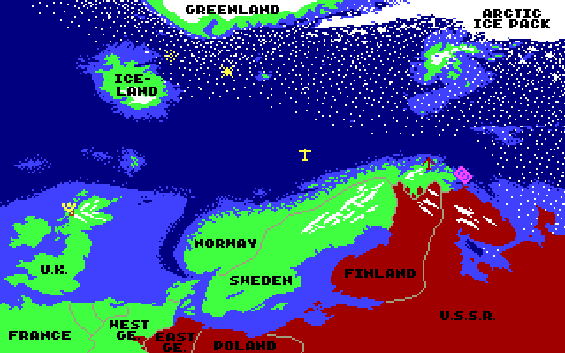
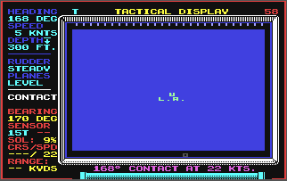
Above is a screen taken from the game. It includes a map showing the location of the submarine and if enemies show up, their relative positions to the submarine. On the left of the map is much vital information, on the upper half is information about the player’s submarine movement, and on the bottom half is information pertaining to an enemy contact. Players may find such a screen especially useful as it is information dense without being overwhelming.
Tom Clancy's Red Storm Rising (PC/DOS) 1989, MicroProse
Games PC RED STORM RISING User Manual (manualmachine.com)

silent hunter 1 (1996)

This is another MS-DOS submarine game released in 1996. It is a newer title than Red storm rising, and as such features better graphics and better quality of life features.
Silent Hunter 1 Content Review & Gameplay
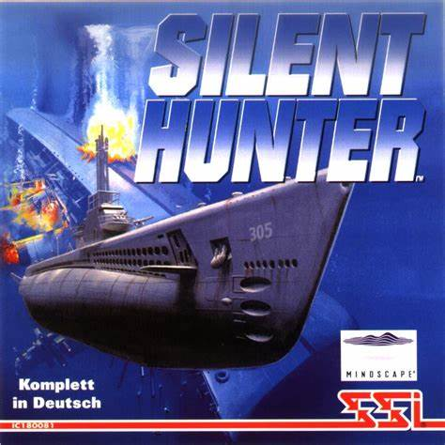

Some features I would like to take are the various screens filled with all sorts of dials containing large volumes of vital information, making the game slightly more challenging as you probe each screen for the information you want, and improves immersion. It also features a periscope view of the surface, which also would be interesting to add.

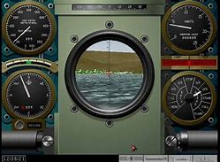
This a screen from the game showing the periscope view. It features a central periscope view and 4 gauges in either corner. These would be an interesting way to display information, adding to the tension of the game as you frantically try to read off the dials, but would be complex to add. The periscope view would require 3d graphics which I am not using.

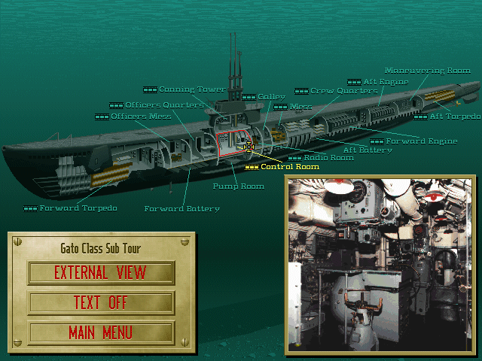
The above screen allows the player to travel around their submarine by selecting the section they want to be in. In my game, the player will only need to be in the control room issuing orders so this is also a feature that while would be nice, would not fit with my concept.

cold waters (2016)
Developed as a spiritual successor to Red storm rising, Cold waters is a modern take on the genre with modern graphics and QOL.
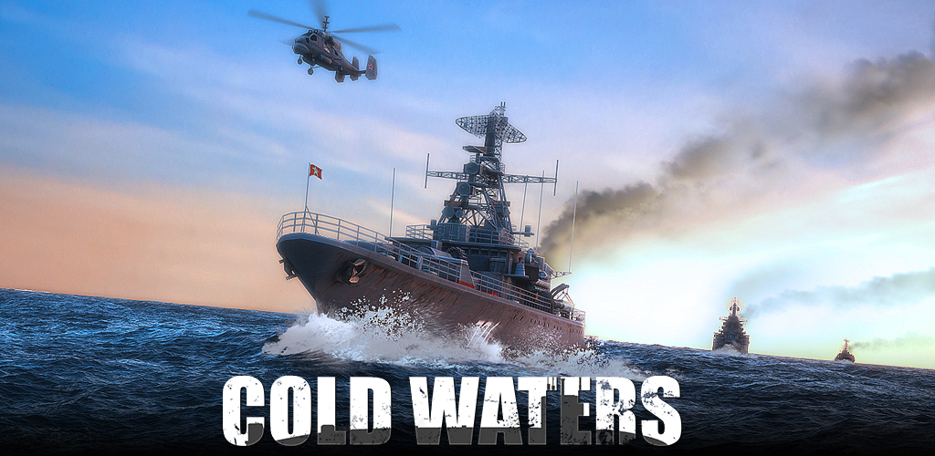
Features
- Real-time naval combat
- Over 40 classes of ships and submarines all meticulously researched
- Dynamic Campaign where your performance matters
- Realistic sonar model
- Authentic Soviet combat tactics
- Actual world-based terrain and depths
- Extensive modding support
- Aircraft, helicopters, dipping sonar, aerial torpedoes, and depth bombs
- Historically based ships, aircraft and weapons
- Museum of ship, aircraft, and weapon statistics
- Control wire-guided torpedoes
- Countermeasures: noisemaker, decoy, chaff, knuckle

3.1.5 Specify the proposed solution

Specify the Limitations of the proposed solution
I am using python to create the game as it is the programming language I have the most experience in, but it is not ideal for game creation despite game engines for it existing.

Specify the Hardware and Software needed for the solution
I will develop it on windows 10 so I am unsure of compatibility with other operating systems. The game will not be graphically intensive so will not require powerful gpu hardware.

3.1.8 Specify the Success Criteria
The player can control the movement of their submarine through commands to change bearing, depth, and speed.
They will be able to fire weapons through commands to target enemy ships by either firing them in the general direction of an enemy if they are intelligent and self-homing weapons, or by specifying a target through their estimated location or code name assigned at detection.
The player will receive information through a map screen, sonar scope screen and sensor screen to determine their best course of action.
Enemy ships will attempt to find and destroy you through their ai which determines a course of action intelligently through information they receive. This will come in the form of movement and weapon firing.
There will be a map with depth values that a player can collide with if they are not careful.

B. Design of the solution

3.2.1 Decompose the problem

3.2.2 Describe the solution

Algorithms

Usability

Variables

3.2.3 Describe the approach to testing

Testing during implementation

Testing post-production

Systems diagram

C. Developing the coded solution (“The development story”)

3.3.1 Iterative development process

3.3.2 Testing to inform development

D. Evaluation

3.4.1 Testing to inform evaluation

3.4.2 Success of the solution

3.4.3 Describe the final product

3.4.4 Maintenance and development

Project Appendixes

